

**MARUZI SEED SECONDARY SCHOOL**

**END OF TERM II EXAMINATIONS 2023**

**S.3 PHYSICS**

|  |  |  |  |
| --- | --- | --- | --- |
| **STUDENT’S NAME** |  | **STREAM** |  |

**INSTRUCTIONS**

* Attempt all questions in section A and any two from section B
* Any additional question(s) answered will not be marked

***FOR EXAMINERS’ USE ONLY***

Do not write in these boxes. The examiners will use them to keep a record of your marks

|  |  |  |
| --- | --- | --- |
| **Questions** | | Marks |
| Section A | |  |
| Section B | No6 |  |
| No7 |  |
| No8 |  |
| Total | |  |

**SECTION A**

1. Two men went to buy a land and were made to tour two pieces of land A of dimensions 50m by 180m and land B of dimensions 100m by 100m. as a physics student with a valid explanation, advise the two men on which land to buy if the two pieces are of the same price.

…………………………………………………………………………………………………………………………………………………………………………………………………………………………………………………………………………………………………………………………….…(04mks)

1. (a) The Sun emits heat energy to the earth through space, state the mode of heat transfer from the Sun to the Earth.

…………………………………………………...........……………(01mrk)

(b) explain why a person near the calm conditions at night feels a cool breeze from the land.

……………………………………………………………………………………………………………………………………………………………………………………………………………………………………….……(03mrks)

1. A student set up an experiment as shown below.

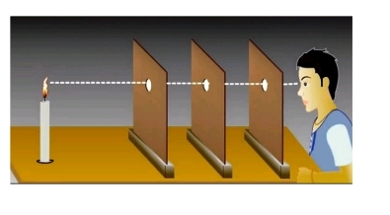

1. What principle was the student investigating?

………………………………………………………………………...(01mrk)

1. Explain what is observed if one of the cardboard is slightly pushed off the line such that the holes are no longer in a straight line

………………………………………………………………………………………………………………………………………………….. (02mrks)

1. What conclusion can you make from 3(b) above.

…………………………………………………………………. (01mrk)

1. 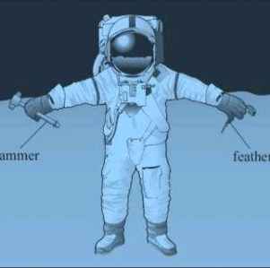An astronaut has a mass of 65Kg on earth, where the acceleration due to gravity is 10m/s2

(a) Calculate the astronaut weight on earth.

………………………………………………………………………………………………………………………………………………. (02mrks)

(b) The astronaut a moon landing. On the moon, the gravitational strength is 1.6m/s2. Calculate the weight of the astronaut on the moon.

……………………………………………………………………………………………………………………………………………………………………………………………………………………….………………….. (02mrks)

1. 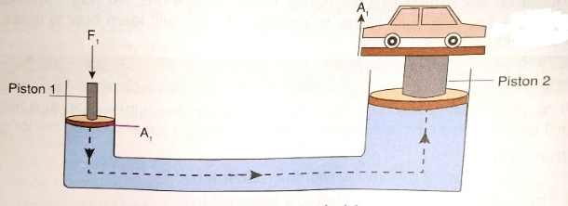The Head teacher’s vehicle got a mechanical break down and need to be lifted using a hydraulic press.

The piston of a hydraulic press has their area given as 3.0×10-2m2 and 2×102m2 respectively. If a student pushes down a smaller piston with a force of 120N. what is the force that will be exerted on the vehicle.

………………………………………………………………………………………………………………………………………………………………………………………………………………………………….……………………………………………………………………………………………. (04mrks)

**SECTION B:**

1. Along Kamdini to Kampala highway, a vehicle of mass 1500Kg travelling at a velocity of 72Km/h towards Kampala collided with a stationary vehicle of mas 900Kg packed in kyriandongo town.

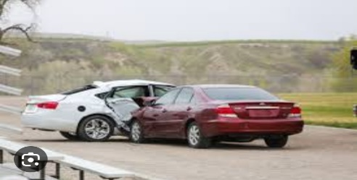

After collision, the two moved together at a constant velocity for 20 seconds. Calculate the;

(a) common velocity after the impact (03mrks)

(b) distance moved after the impact (03mrks)

(c) loss in kinetic energy after collision. (04mrks)

1. In an experiment to demonstrate the properties of the three major states of matter, these were compared based on shapes and volume, compressibility, rigid (fluid), fill container completely.
2. Study the table below showing summary of observations and complete the behavior of each state in each property……………………………. (06mks)

|  |  |  |  |  |
| --- | --- | --- | --- | --- |
|  | Shape and volume | Compressibility | Rigid(liquid) | Fill container completely |
| Solids |  |  |  |  |
| Liquids |  |  |  |  |
| Gases |  |  |  |  |

1. It was observed that solids are incompressible. Explain why a sponge is compressible and yet it is said to be a solid………………………... (02mks)

State any two properties of plasma as a state of matter…………… (02mrks)

1. 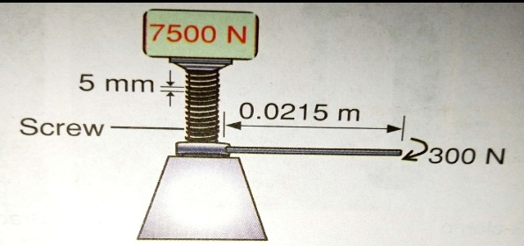A mechanic in one of the garage used the machine below to lift a lorry of 7500N.
2. Identify the name of the machine (01mrk)
3. Determine the;
4. Mechanical advantage (03mrks)
5. Velocity ratio (03mrks)
6. Efficiency of the machine (03mrks)